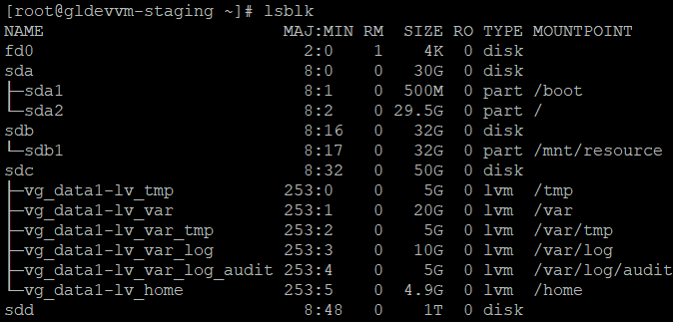

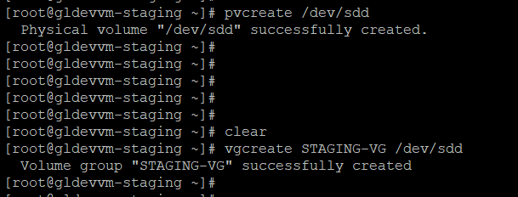

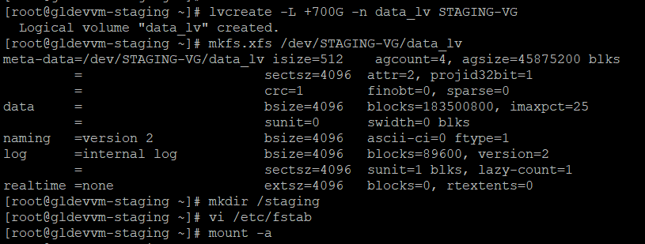

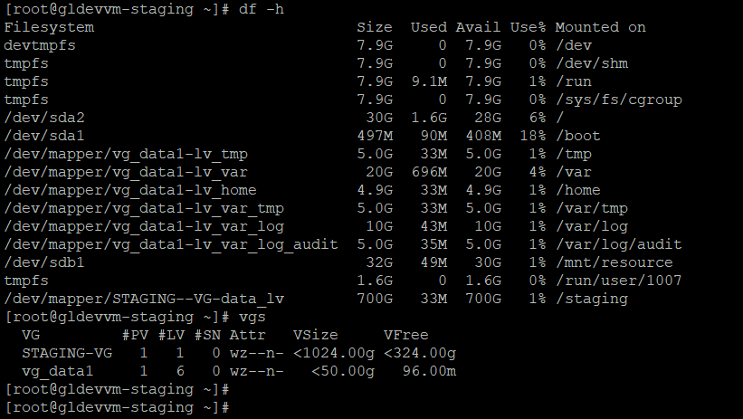

lsblk

df -h

lsblk

pvcreate /dev/sdd

vgcreate STAGING-VG /dev/sdd

lvcreate -L +700G -n data_lv STAGING-VG

mkfs.xfs /dev/STAGING-VG/data_lv

mkdir /staging

vi /etc/fstab

mount -a

df -h

vgs

df -h

